Palmetto Amateur Radio Club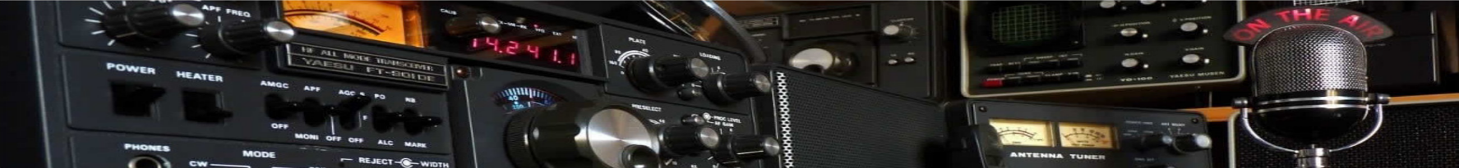
Membership Application Form
□ Single Annual Membership: $20.00 | □ Family Annual Membership: $35

Name: |  | Callsign: |  |  | FRN#:
Address:
City: |  | State: |  |  |  | Zip:
Phone: |  | eMail:

Are you an ARRL Member? □ Yes □ No | Years you have had an Amateur Radio License?

License Class: |  | Expiration Date:

□ You agree to be of good moral character, abide by the Palmetto Amateur Radio Club Bylaws and conduct yourself in a manner that will bring honor and respect to the "Palmetto Amateur Radio Club and its members”.
□ I have read and agreed to abide by all the FCC rules and regulations as codified in Title 47 of the Code of Federal Regulations (CFR), as well as the Palmetto Amateur Radio Club Bylaws.
□ I have never been arrested or convicted of a felony nor placed on supervised probation.

Print Name |  | Signature |  | Date
(The board of directors reserves the right to refuse any applicant without stated cause.)

(Please make Checks Payable to: “Palmetto Amateur Radio Club, Inc.")
Palmetto Amateur Radio Club, Inc.
2621 NW 105 Lane
Sunrise, Florida 33322

Palmetto Amateur Radio Club Official Use Only
Application & Dues Received by the Club Secretary: |  | O Yes O No | Date:
Amateur Radio License Checked: O Yes O No
Meets all requirements as a Regular Club Member: O Yes O No
Membership Accepted or Rejected by (President or Vice President): |  |  | O Accepted  O Rejected |  | Date:
Comments:
www.palmettoarc.org Info@palmettoarc.org

